Royal Falkland Islands Police Firearm Safety Advise
Private Owners Guide
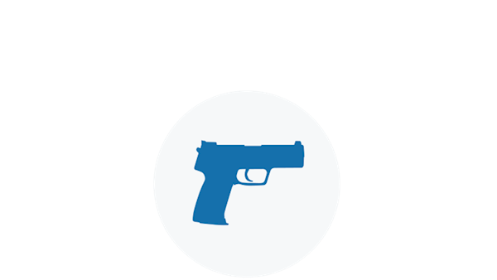
ALWAYS Keep The Gun Pointed In A Safe Direction
This is the primary rule of gun safety. Common sense dictates the safest direction, depending on different circumstances.

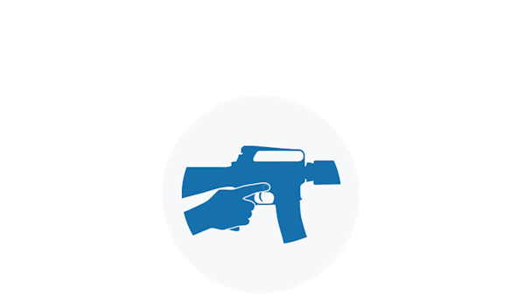

ALWAYS Keep Your Finger Off The Trigger Until Ready To Shoot
When holding a gun, rest your finger alongside the frame and outside the trigger guard. Until you are actually ready to fire, do not touch the trigger.

ALWAYS Keep The Gun Unloaded Until Ready To Use
If you do not know how to open the action or inspect the chamber(s), leave the gun alone and get help from someone who does.
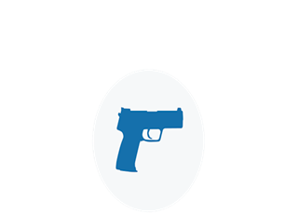
Know your target and what is beyond.
Be absolutely sure you have identified your target beyond any doubt. Equally important, be aware of the area beyond your target. This means observing your prospective area of fire before you shoot. Never fire in a direction in which there are people or any other potential for mishap. Think first. Shoot second.
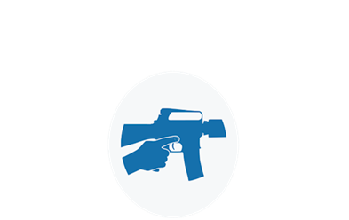

Know how to use the gun safely.
Before handling a gun, learn how it operates. Know its basic parts, how to safely open and close the action and remove any ammunition from the gun or magazine. Remember, a gun's mechanical safety device is never fool proof. Nothing can ever replace safe gun handling.
Be sure the gun is safe to operate.
Just like other tools, guns need regular maintenance to remain operable. Regular cleaning and proper storage are a part of the gun's general upkeep. If there is any question concerning a gun's ability to function, a knowledgeable gunsmith should look at it.
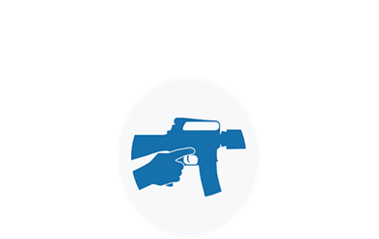
Use only the correct ammunition for your gun.
Only bullets or cartridges designed for a particular gun can be fired safely in that gun. Most guns have the ammunition type stamped on the barrel. Ammunition can be identified by information printed on the box and sometimes stamped on the cartridge. Do not shoot the gun unless you know you have the proper ammunition.

Wear eye and ear protection as appropriate.
Guns are loud and the noise can cause hearing damage. They can also emit debris and hot gasses that could cause eye injury. For these reasons, shooting glasses and hearing protection should be worn by shooters and spectators.
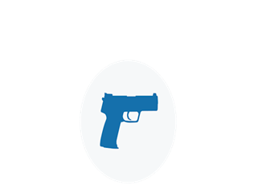
Never use alcohol, or drugs before or while shooting.
Alcohol, as well as any other substance likely to impair normal mental or physical bodily functions, must not be used before or while handling or shooting guns.
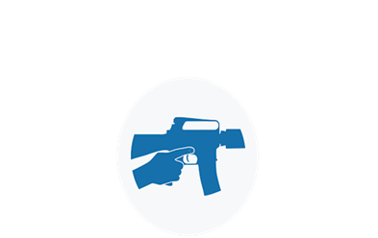
Store guns so they are not accessible to unauthorized persons.
Many factors must be considered when deciding where and how to store guns. A person's particular situation will be a major part of the consideration. Dozens of gun storage devices, as well as locking devices that attach directly to the gun, are available. However, mechanical locking devices, like the mechanical safeties built into guns, can fail and should not be used as a substitute for safe gun handling and the observance of all gun-safety rules.

Cleaning
Regular cleaning is important in order for your gun to operate correctly and safely. Taking proper care of it will also maintain its value and extend its life. Your gun should be cleaned every time that it is used.

A gun brought out of prolonged storage should also be cleaned before shooting. Accumulated moisture and dirt, or solidified grease and oil, can prevent the gun from operating properly.

Before cleaning your gun, make absolutely sure that it is unloaded. The gun's action should be open during the cleaning process. Also, be sure that no ammunition is present in the cleaning area.

*REMEMBER*
Always ensure firearms and ammunition are lawfully held at all times, this is your responsibility and legal action may be taken against you if this is not upheld.

*RFIP offer a free Firearms Clinic which can assist you in firearms security within the home, covering any questions in regards to your firearms, safe handling, maintenance and even licencing. A home assessment can also be arranged assist sighting and give advice on gun cabinet/gun safe fitting.
*This is not a training course.
*Free Safe handling lessons can also be provided at request.
Please contact RFIP Firearms Officer, Police Sergeant Glen Smith :-
Tel: 28100
Email: gsmith@police.gov.fk

