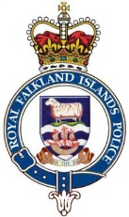
PUBLIC MEETING NOTICE ROYAL FALKLAND ISLANDS POLICE

The Royal Falkland Islands Police will be holding a Public Meeting to give a general overview of the work being carried out by the Police. Members of the public are encouraged to attend and are allowed to ask questions during the meeting.

WHEN: Wednesday, 30th October 2019
TIME: 1800 to 1930 Hrs
WHERE: Town Hall, Stanley

